**IOT Based Smart Water management**

A Project report submitted in partial fulfilment of the requirements for the degree of B.E-Computer Science and Engineering

By

J.SHIYAM SUNDAR (513221104024)

# Under the supervision of

Professor & HOD

Department of B.E-Computer Science and Engineering

# ***PHASE 2: INNOVATION***

✓ Sensus provides water suppliers and utility networks with sensor and data solutions for smart water management. Their toolkits include hardware for smart metering and reading, data analytics and customer portals as well as specific solutions for leak prevention and regulations compliance.

## Rain and stormwater management

**Companies like** [**Raingrid t**](https://www.raingrid.com/)**urn rain and stormwater into a water resource able to fully provide water needs for independent households and the whole neighborhoods. The company designs and implements IoT and data solutions to harvest rainwater and transform it into a major water source for off-grid communities.**

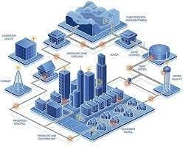

* This approach shows how the application of Internet of Things in water resources management helps unlock the new options for more sustainable and resilient living.

## Smart water monitoring

* [Adcon i](https://www.adcon.com/solutions/)s a smart water company that provides a wide range of water management services from leakage detectors to irrigation management and rainwater monitoring.
* One of the company’s solutions is focused on smart water measurement and quality monitoring for different businesses in the supply chain — farmers, meteorologists, utility services, etc.
* The solution includes sensors, stations, telemetry units and software which processes generated data and creates insights for the decision makers.
* At Digiteum, we design and develop IoT software and big data applications for sustainable and resilient use of resources.

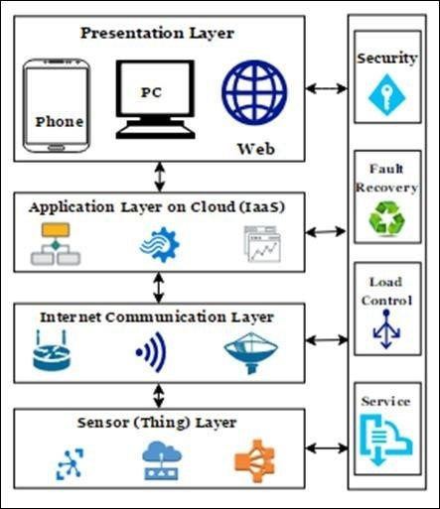

### Benefits of using IOT For Water Management

IoT solutions for water management help industry stakeholders, governments and average consumers reach their sustainability and efficiency objectives. Today, the concept of

IoT in this sector already translates into a brand new idea — the Internet of Water. It requires connecting all the systems and players in the water supply chain — water sources, treatment plants and industrial water management systems, distribution facilities, utility and clean energy companies, and consumers, etc. and empowering decision-makers with important insights on the state of water resources and equipment used in the supply chain.

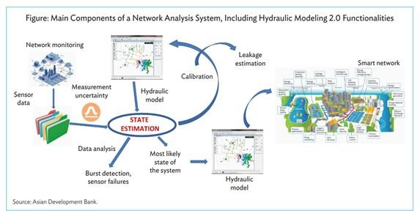

# **Five innovative solutions to water management:**

* Reducing waste of water-intensive industries.
* Monitoring water quality to fight pollution and diseases.
* Improving the efficiency of water systems.
* Creating awareness of household water use thanks to smart meters.
* Providing running water through innovative solutions all around the world.

THANKINGYOU